find Assignment
Mandatory:
- Search and display all *.c and *.h files in all subdirectories starting from current directory
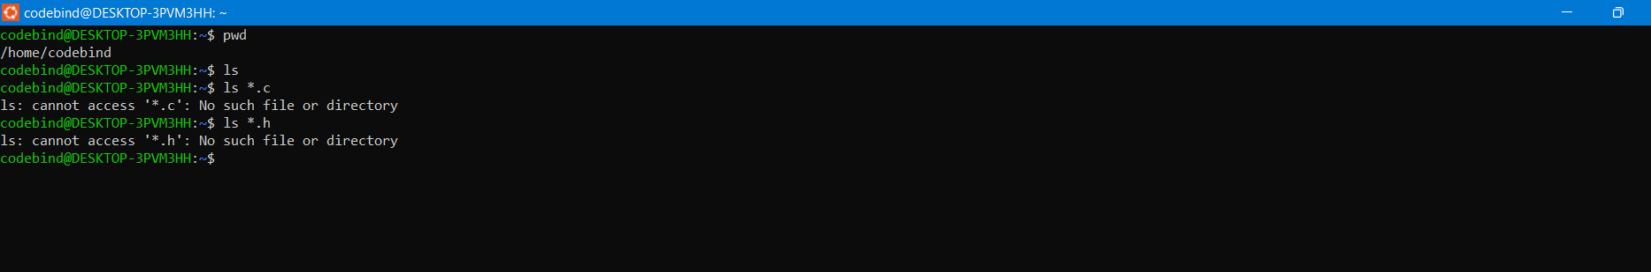

- Search and display all directories in all subdirectories starting from current directory

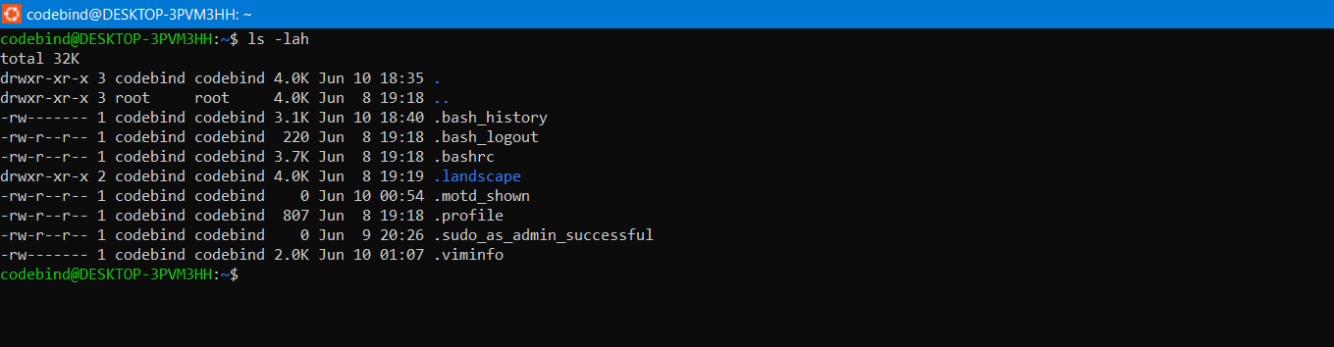
- Search and display all files with permissions only rw with user and execute permission for other
s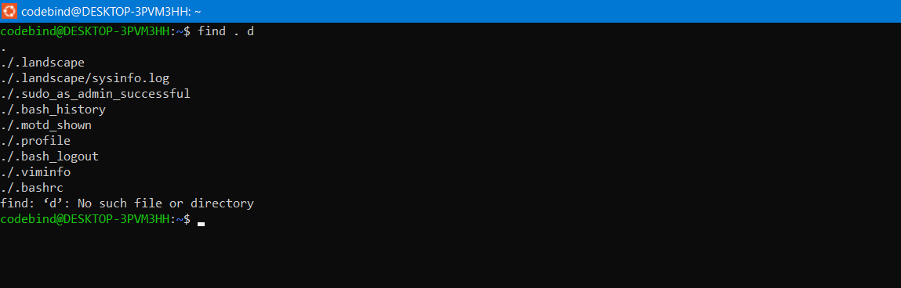
Optional Assignments:
- Search and copy all files whose size is < 500 bytes to a directory named “backup”
- Starting from home directory , find and display all
    - empty files
    - readonly files
    - all empty directories
- Search for a user input pattern in a set of files, extract all lines with the pattern , redirect to a file and display the contents of the file
- Search and display all files which were modified in last 15 days
- Search and display all file which were modified in last 10-15 days
- count the number of words in all *.txt files in a directory and display
- In a given directory sort all files based on their size (descending order) and then read and display the contents of each file

